Time Series Forecasting Report

Time-series description

In December 2019, individuals began to experience pneumonia-like symptoms of this perplexing illness. At the beginning of the year 2020, the innovative agent was classified as coronavirus 2 (SARS-CoV-2), the root of the outbreak in Wuhan China. It spread quickly across the world causing a global pandemic that has taken the lives of many people within the population . Even though there are protective measures,tests and vaccines available to prevent Covid-19, it`s still contractable and can result in death. Short-term forecasting can be helpful in understanding the trajectory of this virus and can provide guidance for what public health efforts should be taken to mitigate the possibility for future pandemics.

For this analysis , I obtained weekly data on confirmed Covid-19 cases across European countries reported by the World Health Organization(WHO) for the years 2020-2022 . The dataset was retrieved from a CSV file and filtered to only include Europe observations . The outcome of interest, New_cases, was aggregated across all European countries to generate a monovariate time series that represents the total daily reported infections. This aggregated dataset contained a total 156 observations . The time series is labeled by date and displays the evolution of the pandemic across several waves. Due to the nature of an infectious disease spread, the data is predicted to exhibit periodic reporting patterns , non-stationarity, and strong temporal dependence .

Exploratory analysis
Initial visualization of the time series presents substantial fluctuations in daily COVID-19 cases, with numerous pronounced peaks indicating major pandemic waves. The biggest spike appears around early 2022, symbolizing a significant rise in infections.

The rolling statistics plot (7-day window) provided powerful insight on the structure of the data. The rolling mean highlights broader trends and smooths short-term fluctuations , while the rolling standard deviation captures the spread of data over time. Both of these measures vary substantially , indicating that the time series is non-stationary with changes in the variance.

The performance of seasonal decomposition confirms the presence of three key components . The first component is the trend , there is a clear long lasting upward and downward movement that displays several waves of infection. The second component is the seasonality , a consistent weekly pattern is present , this is likely due to reduced testing during weekends and reporting delays. The third component is the residual ,there`s abnormal spikes that are specifically during peak outbreak intervals , this suggest the presence of sudden changes in transmission dynamics and external shocks .

Modeling and forecasting
Baseline Model
The baseline model predicts that future values will be equivalent to the latest observed value. While simple, this model acts as an essential benchmark for evaluating methods that are more difficult .
ARIMA Model
An ARIMA model was fitted using trained data. This model identifies temporal dependencies through moving average and autoregressive components. Since this analysis utilizes daily new cases instead of cumulative counts, the differencing method was not applied (d = 0).
Exponential Smoothing Model
An additive Holt-Winters exponential smoothing model was used , incorporating both seasonal and trend components. A seasonal period of 7 days was utilized to capture weekly patterns can be viewed in the data.
Train/Test Split
The dataset was split into testing and training sets using an 80 to 20 ratio while maintaining chronological order. This assures that future observations are not used to traject past cases , sustaining the integrity of the forecasting procedure .

Evaluation
Model performance was evaluated using Root Mean Squared Error (RMSE) and Mean Absolute Error (MAE) , these metrics measure the magnitude of prediction errors.The baseline model accomplished the lowest error values, this indicates that it had the best predictive performance compared to the other three models. The ARIMA model performed fairly well but did not outperform the baseline model . The exponential smoothing model achieved significantly higher errors, indicating that the model fitted poorly .

The graph generated to compare the forecasts further supports these findings. The baseline model follows the observed data closely , while the ARIMA model produces smoother trajections that do not capture sharp fluctuations. The exponential smoothing model separates substantially from the observed values, specifically during periods of rapid change.
Discussion and conclusions
This analysis provided impactful insights and proved why time series forecasting is beneficial for predicting future COVID-19 cases . First, the time series displays strong volatility, non-stationarity, and abrupt structural changes due to growing pandemic conditions. These characteristics can make forecasting values accurately challenging.

Second, the admirable performance of the baseline model suggests that short-term persistence is a strong determinant of daily case counts. This is likely due to the high autocorrelation within the data, where present values are strongly persuaded by recent observations.

Third, the ARIMA model may not have been preferably specified. The absence of parameter tuning and seasonal components likely limited its performance. Using a Seasonal ARIMA (SARIMA) model could be better for capturing weekly patterns observed in the data.

Finally, the exponential smoothing model performed the poorest, likely because the additive structure could not efficiently capture the sudden spikes and extreme variability present in the data. Enormous outbreaks introduce non-linear dynamics that are complex for smoothing-based models to handle.

Future work should include exploring more advanced approaches such as SARIMA models, machine learning methods , or incorporating external variables to improve model`s predictive performance.

Limitations

This analysis has multiple limitations that should be considered when presenting the results. First, there was no hyperparameter tuning performed for the exponential smoothing or ARIMA models. As a result, the selected model conditions may not be preferable , which likely was a contributor to their poor forecasting performance in comparison to the baseline model.

Second, this analysis does not incorporate any exogenous or external variables that may impact COVID-19 case counts. Factors such as vaccination rates,government policies, mobility patterns, and the emergence of new variants can substantially affect transmission dynamics. The dataset`s exclusion limits the predictive and explanatory power of the models.

Finally , the used dataset may contain inconsistencies due to underreporting,reporting delays or changes in testing methods across countries . These irregularities introduce potential bias and noise into the time series, making accurate modeling more complex .

Model | Root Mean Squared Error (RMSE) | Mean Absolute Error (MAE) | Model Performance rank
ARIMA Model | 738,376.84 | 610071.99 | Second
Baseline Model | 303287.07 | 237423.31 | First
Exponential Smoothing Model | 2657136.06 | 2411650.58 | Third

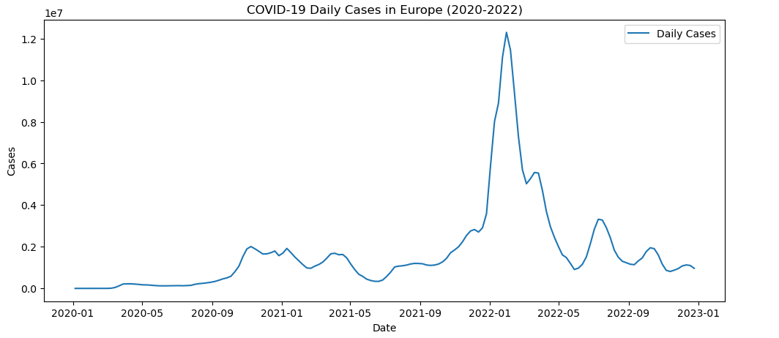

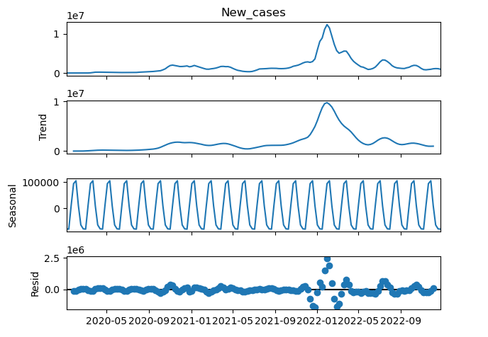
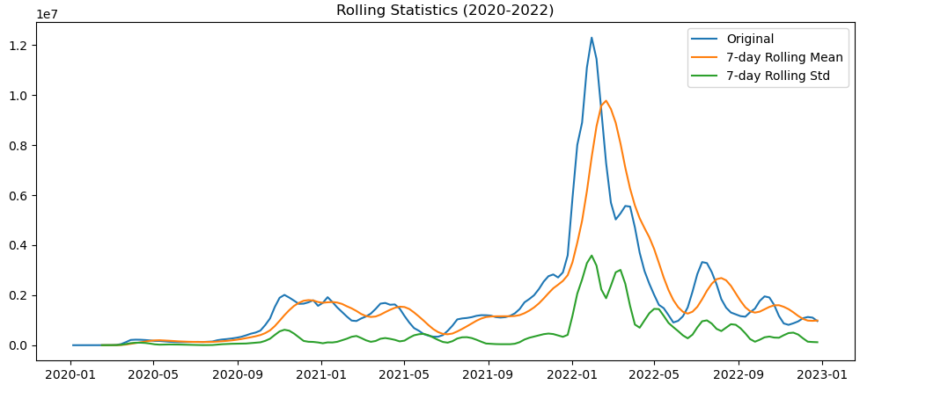

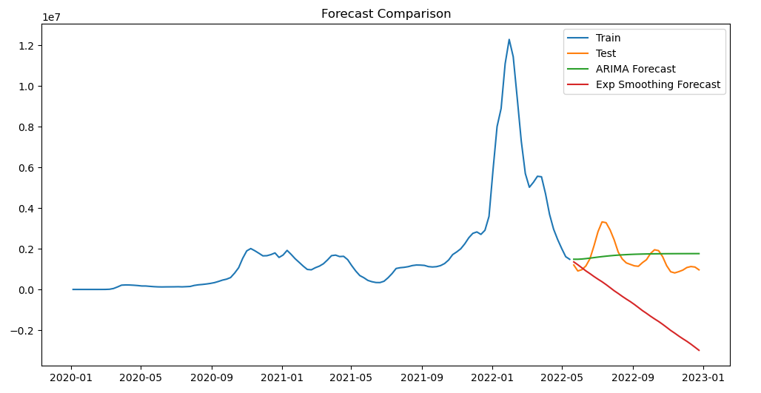

Total Days(count) | 156
Mean | 1720923
Standard Diviation | 2160266
Min | 1
Max | 12296998

References

- European Union. (2023). The common EU response to COVID-19. European-Union.europa.eu. https://european-union.europa.eu/priorities-and-actions/common-eu-response-covid-19_en
- Jihyun (Jenny) Kim. (2024, April 3). Exploring the Seasonal ARIMA (SARIMA) Model for Forecasting: Differences from ARIMA. Medium. https://medium.com/@jihyun.kim423/exploring-the-seasonal-arima-sarima-model-for-forecasting-differences-from-arima-e30c3488e5f6
- Weise, E., & Weintraub, K. (2021, January 17). Where Did COVID-19 Come from? | National Emerging Infectious Diseases Laboratories. Www.bu.edu; Boston University. https://www.bu.edu/neidl/2021/01/where-did-covid-19-come-from/
- Somyanonthanakul, R., Warin, K., Amasiri, W., Mairiang, K., Mingmalairak, C., Panichkitkosolkul, W., Silanun, K., Theeramunkong, T., Nitikraipot, S., & Suebnukarn, S. (2022). Forecasting COVID-19 cases using time series modeling and association rule mining. BMC Medical Research Methodology, 22(1). https://doi.org/10.1186/s12874-022-01755-x

